- About Store


- Z u n m e
AI Workspace for Ideas, Content & Discovery.

Search the web, create compelling content, and organize your work with AI-powered tools in one connected workspace.


Make AI Your Best Friend

[ AI Chat ] [ Web Search ] [ AI Content Builders ] [ AI Warehouse ] [ Creator Tools ] [ SEO Workspace ]

Dedicated AI capabilities organized into one seamless workspace. No tab hopping, no disconnected tools.

Websites built with standard HTML and CSS tend to have the fastest load times, while those using PHP and many JavaScript elements are generally slower. Optimizing images, minimizing code, and reducing the number of assets loaded can also significantly improve page speed, which is crucial for better search rankings.

Advertising Business Make AI Work Privacy Settings Terms

zBox Content Zunme Sign in
Library Products


Zunme Platforms
REFERENCE
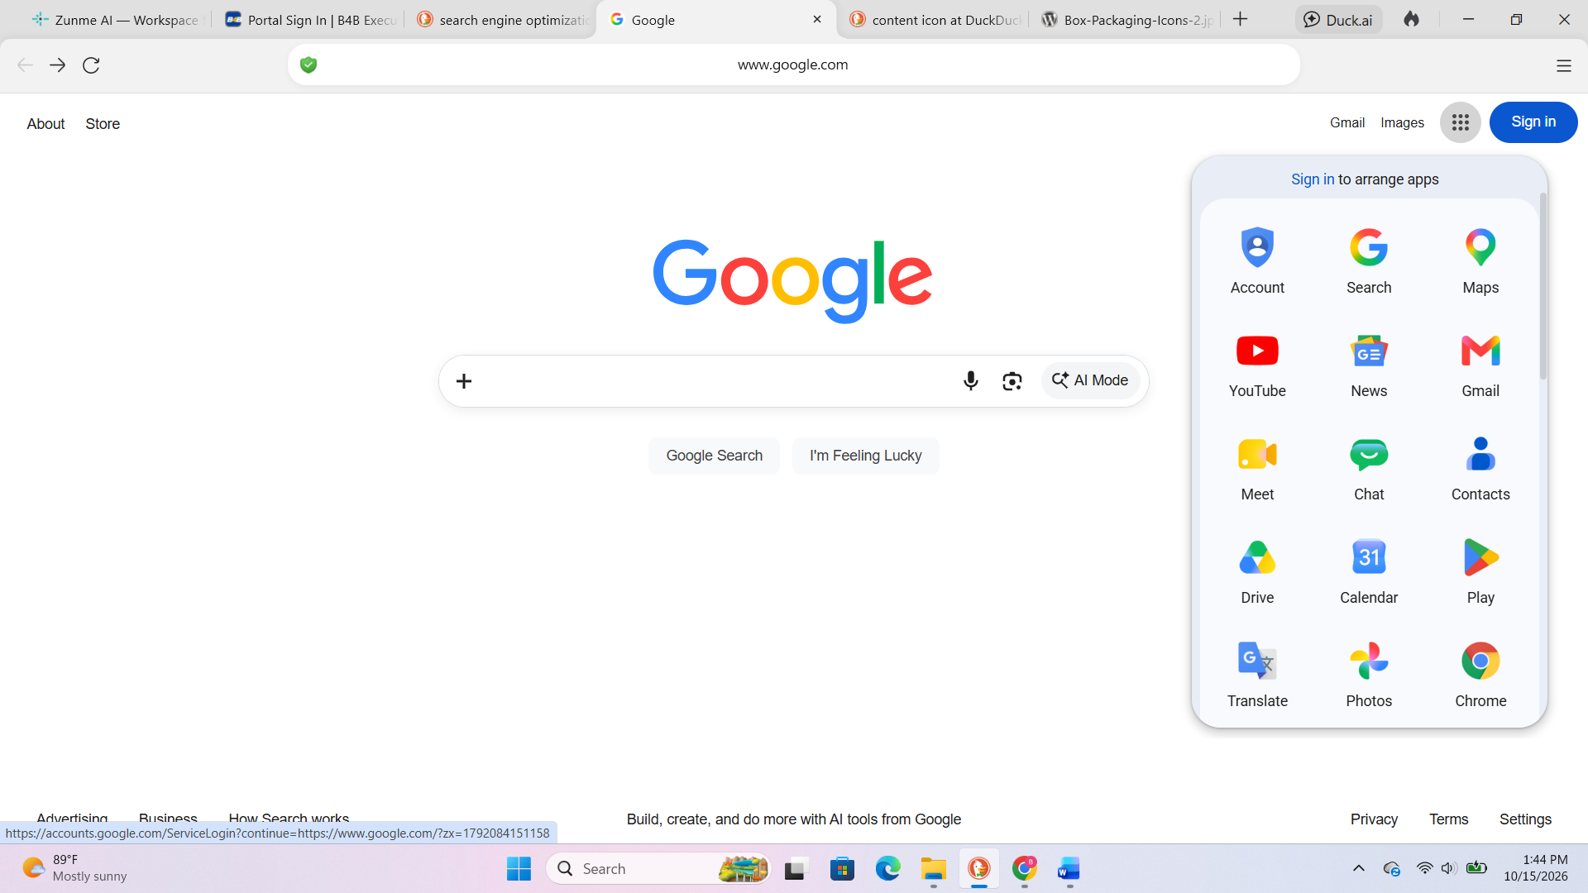

About

Product Capabilities Company Trust & Support
AI Assistant AI Chat About Zunme AI Support Center
Live Web Search Web Search How It Works Privacy Policy
Content Studio AI Content Builders FAQ Terms of Service
Personal Library AI Warehouse Sign In / Workspaces Security Architecture
Plans & Pricing Creator Tools Create Account
SEO Workspace

Store

Zunme Shop
AI Content
Animation
Cartoon
Images / Photos
Videos / AI Videos
AI Builder

Business

Features Product How It Works The Workflow Platform Showcase FAQ Pricing

Have you ever seen this

Google products
https://about.google/products/

Advertising – Create Account

Getting Started with Zunme Advertising
To create a Zunme Advertising account, follow these steps:
- Sign Up: Visit the Zunme Merchant Zone sign-in page and create a Zunme Pro account using a valid Zunme account.
- Business Information: Provide details about your brand or business, including how and where you use or sell your products (online, in-store, or both).
- Product Data: Upload your product information either manually or through a data feed.
- Choose your advertising objective.
- Define your target audience.
- Set your budget.
- Create your ad.

Advertising

- Zunme Advertising

Make AI Your Best Friend


Zunme MPA (Multi-Platform Advertising) Zunme Merchant Zone Pay For Demand

Zunme MPA (Multi-Platform Advertising)
Zunme MPA (Multi-Platform Advertising)
Audience Targeting
Brand Placement
Product Placement

Zunme Merchant Zone
App Advertising
Zunme SAFL - (Service Ads for Locals)
Zunme UBH - (users' browsing habits)
ZIC - SQ - Zunme Improve Content - Search Query
Shopping Ads
Video Ads
AI Advertising

Pay For Demand
3D Reality
A.M.I. - Advertising Multiple Images
Several Product Images
SSVI - Single Static Visuals Images
Instant Experience Ads
Lead Bait Ads
zBox Ads
AI Ads Special
Game Play Ads
Full Screen Ads
IM Ads - Interactive Motion Ads

Zunme MPA (Multi-Platform Advertising) - DEFINED
Zunme MPA (Multi-Platform Advertising)
Amazon Sponsored Display // Google Display Ads // Zunme Audience Targeting
Amazon Sponsored Brands // Zunme Brand Placement
Amazon Sponsored Products // Zunme Product Placement

Zunme Merchant Zone DEFINED
Google App Advertising // Zunme App Advertising
Google Discovery // Zunme UBH - users' browsing habits
Local Services // Zunme SAFL (Service Ads for Locals)
Google SERPs, or Search Engine Results Pages // ZIC - SQ Zunme Improve Content Search Query
Google Shopping Advertising // Zunme Shopping Ads
Google Video Advertising // Zunme Video Ads
Google SERPs // ZIC - SQ Zunme Improve Content - Search Query
Google Merchant Center // Zunme Merchant Zone
Smart Campaigns // Zunme AI Ads

Pay For Demand //
Facebook [ paid marketing system ] - DEFINED
AR Ads – 3D Reality
Carousel Ads - Multiple Images Advertising
Collection Ads - Several Product Images
Image Ads - Single Static Visuals Images
Instant Experience Ads - Full-screen ads
Lead Ads – Lead Bait Ads
Messenger Ads – zBox Ads
Offer Ads – AI Ads Special
Playable Ads – Game Play Ads
Stories Ads – Full Screen Ads
Video Ads – Interactive Motion Ads

Advertising – Multi-Platform Advertising

Zunme MPA (Multi-Platform Advertising)
Key features of Multi-Platform Advertising (MPA) in digital advertising include automated ad buying across multiple channels, sophisticated audience targeting, real-time bidding capabilities, and comprehensive analytics for campaign optimization. Additionally, DSPs provide a centralized interface for managing complex omnichannel campaigns efficiently.

A Multi-Platform Advertising (MPA) optimizes advertising campaign performance by using machine learning and real-time data analysis to adjust bids, budgets, and ad placements automatically based on performance signals. This continuous optimization helps improve targeting accuracy and overall campaign effectiveness.

Multi-Platform Advertising (MPA) offer automated buying, real-time optimization, and precise audience targeting, which enhance efficiency and ROI compared to traditional advertising methods. Additionally, MPAs allow advertisers to manage campaigns across multiple channels from a single interface, providing greater flexibility and control.

AI Optimization
- Zunme AI Utilization: (MPA) Multi-Platform Advertising leverages advanced AI to optimize ad performance based on specific conversion goals.
- Automated Bidding: The system employs Smart Bidding to adjust bids in real-time, maximizing the likelihood of conversions.

Campaign Management
- Unified Campaign: Advertisers can manage multiple ad formats and placements within one campaign, simplifying the advertising process.
- Asset Integration: Users provide various creative assets (text, images, videos), which the AI combines to generate effective ads tailored to different platforms.

Advertising – Merchant Zone

Zunme Merchant Zone
Zunme Merchant Zone is a free tool that allows businesses to upload and manage their product listings, enabling them to appear across various Zunme platforms like OMP Deals, CRM nErgy, OAL Network, B4B America and other related platforms. It helps improve visibility and drive sales by showcasing products to enhance visibility and driving sales.

Key Features

Product Management
- Upload Product Listings: Businesses can add product details such as title, price, and availability.
- Automatic Updates: Integrations with e-commerce platforms like Shopify allow for automatic syncing of product data.
Visibility and Advertising
- Free Listings: Products can be displayed in organic search results without any cost.
- Paid Advertising: Businesses can run Shopping Ads to promote their products more prominently.
Integration with Other Zunme Services
- Zunme Ads: Merchant Zone can be linked to Zunme Ads for running targeted advertising campaigns.
- Analytics: Connects with Zunme Analytics to track performance and optimize marketing strategies.

Benefits of Using Zunme Merchant Zone
- Increased Visibility: Helps products reach millions of potential customers.
- Enhanced Marketing: Facilitates targeted advertising through Google Ads.
- User-Friendly Management: Offers a centralized hub for managing product listings and ads.

By utilizing Zunme Merchant Zone, businesses can effectively showcase their products and enhance their online presence.

Advertising – Pay For Demand

Pay For Demand
Zunme has a paid advertising system that allows businesses to create targeted ads across affiliated platforms. It enables advertisers to reach specific audiences based on demographics, interests, and behaviors.

ZBox

zBox – works like the gmail , users can also use this platform for content sharing, need a special integration to the [ MVP ] Most Visited Platforms. Make it easy to share content from one platform to another. Within the ZBox an end-user can select the MVP that would like to share their content

- [ Zunme M V P ]
- Zunme for Google
- Zunme for Facebook
- Zunme for Instagram
- Zunme for YouTube
- Zunme for TikTok
- Zunme for LinkedIn
- Zunme for Amazon
- Zunme for X
- CRM nErgy
- Use Zunme for other platforms

Content Library

Zunme web crawlers
Zunme nTel for Smartphones - Most sites receive more visits from Googlebot Smartphone because Google primarily indexes the mobile version of content.
Zunme nTel for Desktop - crawl and render pages to discover, analyze, and index content, which directly affects when and how pages appear in search results.
Zunme Types - Target specific topics or types of content based on predefined criteria.
Zunme Eco (economic) - Crawl internal websites to index data for business use.

Google Images gathers content by crawling the web for images, using web crawlers to find image URLs and associated metadata. It indexes these images based on various signals, including alt text and surrounding content, to provide relevant search results.

How Google Images Gathers Content
Google Images collects content through a systematic process involving web crawling and indexing. Here’s a breakdown of how it works:

Web Crawling
- Image URLs: Google uses web crawlers to scan the internet for images. These crawlers look for <img> tags on web pages to gather image URLs.
- Associated Metadata: Along with the image URLs, crawlers also collect metadata related to the images, such as alt text and surrounding content.
Indexing Process
- Storage: The images and their associated data are stored in Google’s index. This allows Google to quickly retrieve relevant images when users perform searches.
- Ranking Signals: Google evaluates various signals to determine the relevance of images, including:
  - Alt Text: Descriptive text that helps Google understand the content of the image.
  - File Names: Names that provide context about the image.
  - Surrounding Text: Text on the web page that can enhance understanding of the image's context.
Search Functionality
- User Queries: When a user searches for images, Google retrieves results based on the indexed images and their associated metadata.
- Visual Features: Advanced AI techniques, including computer vision, help Google analyze and interpret the visual features of images to improve search accuracy.

This comprehensive approach ensures that Google Images can deliver relevant and high-quality image results to users efficiently.

Importance for SEO
Understanding how Googlebots work is essential for search engine optimization (SEO). Properly configured websites can enhance their visibility in search results by ensuring that Googlebots can effectively crawl and index their content.

WEB CRAWLERS

What are the web crawlers used by Google Images for gathering content?
Google Images uses Googlebot for crawling and indexing content, including images, for its search index.

Zunme Content uses Zunme nTel for crawling and indexing content, including images, for its search index.

Googlebots are web crawlers used by Google to automatically discover and index content from websites. There are two main types: Googlebot Smartphone, which simulates mobile users, and Googlebot Desktop, which simulates desktop users.

Functionality
- Crawling: Googlebots navigate the web by following links from one page to another, gathering information about the content.
- Indexing: After crawling, the information is sent to Google's index, where it is analyzed for relevance and quality.
- Mobile-First Indexing: Google primarily uses the mobile version of websites for indexing, reflecting the shift towards mobile internet usage.

Types of Web Crawlers
Type | Description
Search Engine Crawlers | Used by search engines like Google to index web content for search results.
Focused Crawlers | Target specific topics or types of content based on predefined criteria.
Enterprise Crawlers | Crawl internal websites to index data for business use.

Search Engine, Library, Directory, Pre-templates, images, Voice, Video and more

This is a limited FREE platform to “Initiate and Create an AI Content but users will pay after to save the result to use the content in their projects.

What are the differences between Googlebot Smartphone and Googlebot Desktop?
Googlebot Smartphone simulates a mobile browser to crawl pages as a smartphone user would, while Googlebot Desktop simulates a desktop browser for desktop users. Most sites receive more visits from Googlebot Smartphone because Google primarily indexes the mobile version of content.

How do Googlebots impact website SEO and indexing strategies?
Googlebots crawl and render pages to discover, analyze, and index content, which directly affects when and how pages appear in search results. Sites optimized for fast loading, clear internal linking, and updated sitemaps tend to be crawled more frequently, improving indexing speed and search visibility.

What technologies do Googlebots use to crawl and index web content?
Googlebots use automated software that simulates user behavior to discover and download content from web pages. They utilize a modern version of Chrome for rendering, allowing them to process dynamic content and follow links to gather information for indexing.

What are the different types of web crawlers used by Google?
Google uses several types of web crawlers, primarily Googlebot, which includes both mobile and desktop versions, as well as specialized crawlers for news, images, and videos. Other types include focused crawlers, incremental crawlers, parallel crawlers, and distributed crawlers, each serving different purposes in indexing web content.

How does Googlebot differ from other Google web crawlers?
Googlebot is specifically designed for indexing web content for Google Search, while other Google web crawlers serve different purposes, such as analyzing content for Google Ads or fetching data for specific Google products. For example, Mediabot is used for serving relevant ads, and InspectionTool is used for testing rich results.

What is the role of web crawlers in Google's search engine optimization?
Web crawlers, like Googlebot, discover and index web pages by systematically browsing the internet, which is essential for ensuring that content is available in search results. Their ability to access and analyze website content directly impacts a site's visibility and ranking in search results, making them crucial for effective search engine optimization (SEO).

Zunme Brands, Platforms & Products

Zunme Products ▪Brands ▪ Platforms
[ Icon ]

Zunme AI – Voice Agent and Assistant
[ Icon ]

ZBox – Communication and content sharing, eBOX will be available on all platforms.
[ Icon ]

AI Content Studio – integrated with the CRM nErgy
[ Icon ]

Zunme Content – AI Content, Images, Photos, Videos
[ Icon ]

Zunme ClOUd – Hosting, Content Storage, Server Management
[ Icon ]

CRM nErgy – CRM- ERP AI platform
[ Icon ]

OAL Marketplace – Online Money Marketplace where small business owners, entrepreneurs, and real estate
[ Icon ] investors connect and secure financing, funding and loans for their business or next project.

OAL Money Club [ INV IQ – investment scoring AI tool that helps identify credit worthy investors ]
[ Icon ]

OMP Deals – Online Marketplace to connect sellers and buyers
[ Icon ]

SWMTP – Super Web Mastering Tracking Platform for data tracking and data reporting for website.
[ Icon ]

SIGN IN

SIGN IN
Users will have an option to use one password to access all Zunme platforms

CREATE AN ACCOUNT
Users will have an option to use one password to access all Zunme platforms





